

Spring 2026
GIFT School of Engineering and Applied Sciences

SE-317L: Software Project Management

Lab Manual 7
Resource Management in Microsoft Project
Introduction

In this lab, you will continue working on the University Examination and Management System (UEMS) project in Microsoft Project. This time, you will focus on Resource Management, which is one of the most important skills in project management.

When a project has many tasks running at the same time, problems can happen. For example, one person might be scheduled to work on two tasks at the same time. This is called a Resource Conflict. If these conflicts are not fixed, the project will be delayed and team members will be overworked.

Objectives of This Lab
After completing this lab, students will be able to:
1. Open the UEMS project file from the previous lab in Microsoft Project.
2. Add resources such as team members to your project and assign them to tasks.
3. Identify resource conflicts using the Resource Usage view and Resource Graph.
4. Understand what overallocation means and why it is a problem.
5. Apply automatic Resource Leveling to fix conflicts.
6. Apply manual leveling by adjusting task assignments yourself.
7. Use the Team Planner view to see and fix workload problems visually.
8. Optimize resource usage so no team member is idle or overloaded.
9. Check the updated schedule to make sure the project finish date is still acceptable.
10. Submit your Microsoft Project file with screenshots.
3-Hour Lab Breakdown
Time | Activity
0–30 min | Concept recap
30–90 min | Guided hands-on task
90–150 min | Independent student work
150–180 min | Evaluation + viva + submission

What is Resources?
A resource is anything you need to complete a task. In most projects, resources are people such as developers, testers, and designers. Resources can also be equipment like computers and servers, or materials like software licenses.
What is Resources Conflict?
A resource conflict, also called overallocation, happens when one resource is assigned to do more work than they can handle in a given time period.
What is Resources Leveling?
Resource leveling is the process of fixing resource conflicts. There are two ways to do it. The first is Automatic Leveling, where Microsoft Project fixes the conflicts automatically by delaying some tasks. The second is Manual Leveling, where you fix the conflicts yourself by changing task assignments or moving tasks.
What is Resources Optimization?
After fixing conflicts, you want to make sure your resources are being used efficiently. This means nobody is overloaded with too much work, nobody is sitting idle for too long, and the project finishes as soon as possible.

PART 1: Setting Up Resources in MS Project
Open the Microsoft Project file from Lab Manual 5. Use the work we already completed there, including creating resources in the Resource Sheet and allocating resources to tasks.

PART 2: Identifying Resource Conflicts
Step 1 — Switch to Resource Usage View
The Resource Usage view shows you exactly how many hours each person is working per day. Overloaded days are highlighted in red.
- Click the View tab.
- In the Resource Views group, click Resource Usage.
- You will see a table on the left showing each resource and their tasks.
- On the right side, you will see a grid showing daily work hours for each person.
- Any number shown in RED means that person is working more than 8 hours that day.
- Resources shown in RED text are overallocated.
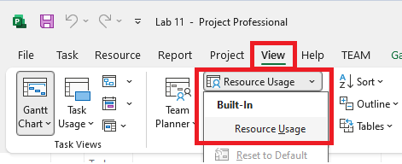

Step 2 — Open the Resource Graph
The Resource Graph gives you a visual bar chart of each person's workload. It is very easy to read and understand at a glance.
- Click the View tab.
- Click the dropdown arrow next to Other Views.
- Select Resource Graph from the list.
- A bar chart will appear showing the workload for the first resource.
- To move to the next resource, press the Page Down key on your keyboard.
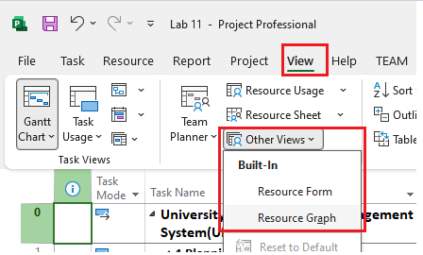

How to read the Resource Graph:
- Blue bars mean the resource is working at a normal level. This is good!
- Red bars mean the resource is overallocated. This is a problem that needs fixing.
- There is a dotted horizontal line showing the maximum available hours, which is usually 8 hours per day.
- Bars going ABOVE the dotted line show a conflict.
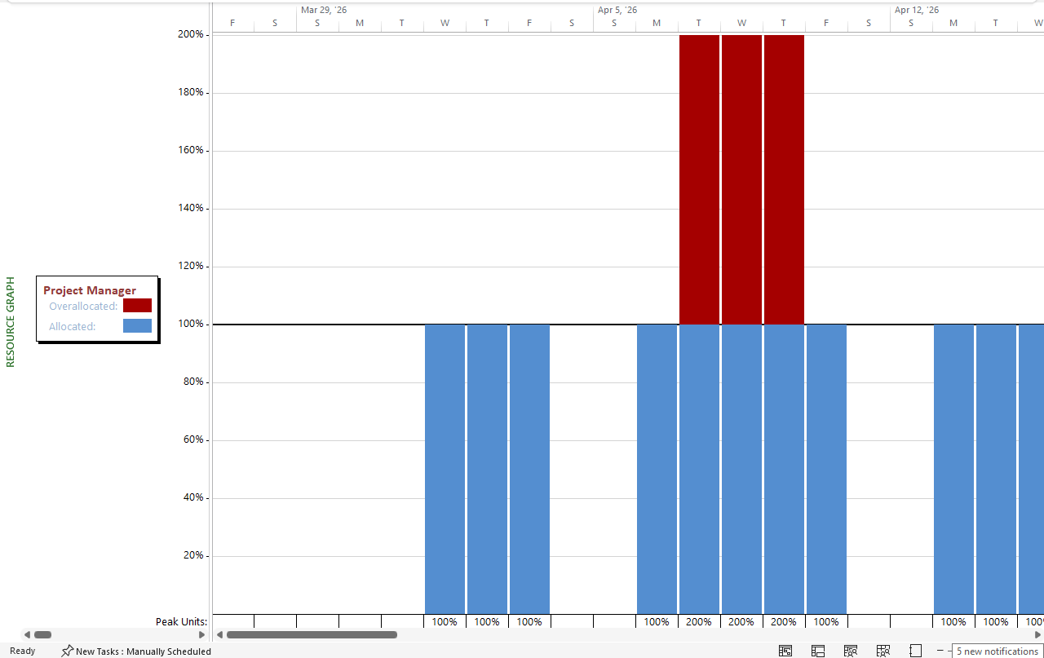

Step 7 — Look for Red Resource Names in the Gantt Chart
You can also see resource conflicts directly in the Gantt Chart view without switching to another view.
- Go back to the Gantt Chart view by clicking View and then Gantt Chart.
- Look at the resource names displayed next to the task bars on the right side.
If a resource name appears in red next to a task bar, that resource is overallocated during that task.
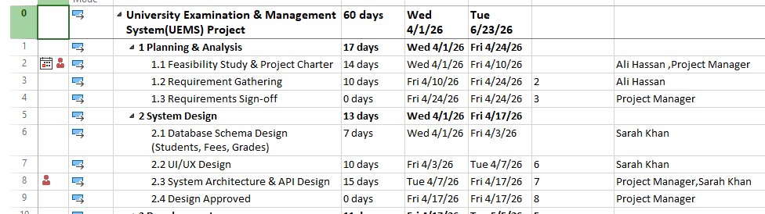
Step 8 — Open the Resource Leveling Dialog
- Click the Resource tab in the ribbon at the top of the screen.
- Find the Level group on the right side of the ribbon.
- Click Level All. This will automatically level all resources at once.
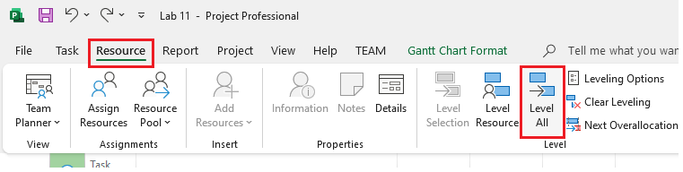
If you want more control over the settings, do this instead:
- Click the small dropdown arrow at the bottom right corner of the Level group.
- This will open the full Resource Leveling dialog box with more options.
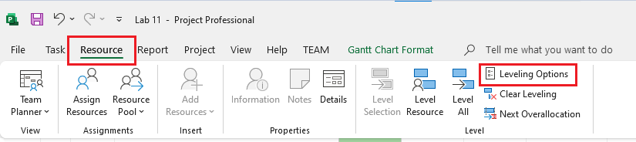

When the Resource Leveling dialog opens, you will see these options. Set them as shown:
Setting | What to Choose | Why
Leveling calculations | Automatic | MS Project will level in real-time as you work
Look for overallocations on a | Day by Day basis | Checks conflicts every day — most accurate
Leveling order | Standard | Good balance of time and priority — best for beginners
Level only within available slack | Leave unchecked first | Gives MS Project more freedom to fix conflicts
Leveling can adjust individual assignments | Check this box | Allows MS Project to split or reassign work
Leveling can create splits in remaining work | Check this box | Allows tasks to be paused and restarted

- After setting these options, click Level All.
- MS Project will now rearrange and delay tasks to remove conflicts.

Step 9 — Manual Resource Leveling
Sometimes automatic leveling does not give the best results. In that case, you can fix conflicts manually. Here are three methods you can use.
- If Developer 1 is overloaded on a task, you can replace them with Developer 2 on that task.
- Instead of removing the resource completely, you can reduce how much time they spend on a task each day. Change their Units from 100% to 50%.
- You can simply move a task to a later date so it no longer overlaps with another assignment.

PART 3: Optimizing Resource Usage
After fixing conflicts, your next goal is to make sure resources are being used in the best possible way. Optimization means no one has too much work and no one has too little work.
Step 10 — Find Idle(Underutilization) Resources
A resource is underutilized if they have a lot of empty time while the project is running. This is a waste of resources and money.
- Go to the Resource Usage view.
- Look for resources that have very low hours per day, for example only 2 hours when they could do 8.
- These resources have free capacity that could be used to help other tasks and speed up the project.
Step 11 — Assign Extra Work to Idle Resources
If you find a resource with a lot of free time, consider assigning them to help with a critical task.
- Identify a critical task that is taking too long.
- Click on that task in the Gantt chart.
- Use the Assign Resources dialog (Task tab > Assign Resources) to add the idle resource to this task.
- This will speed up the task if Effort Driven is turned ON.
- After assigning, go back to the Resource Usage view and check that you have not created a new conflict.
Project Scenario
Scenario — University Student Portal
The University of Punjab has over 40,000 students enrolled across 120 departments. Every semester, students must visit the university in person to register for exams, pay fees manually, and collect their roll number slips from the office. This process takes weeks and causes long queues, lost paperwork, and errors in student records.
When exam results are ready, the university takes 45 to 60 days to calculate grades manually and notify students. Students have no way to check their results online — they must visit the notice board or wait for a letter. Many students also report incorrect marks due to human error.
To address these problems, the university has contracted TechBridge Solutions to build an online system called the University Examination & Management System (UEMS). This web-based portal will allow students to register for exams online, pay fees via mobile, download roll number slips instantly, and view results as soon as they are published.
Teachers will be able to enter marks online, and the system will automatically calculate GPA and CGPA — eliminating manual errors. The Examination Controller will generate reports and publish results in just 15 days instead of 60. The total project budget is PKR 28,00,000 and the deadline is 6 months (March 2025 – August 2025), so that students can use the system from the very next semester.

Lab Task:
- Create a new resource named “Senior Developer”, “Backend Developer”,”AI Engineer”
- Assign these resource to at least 3 critical tasks
- Check whether project duration decreases or not
- Assign one resource to work at: 50%, 100%, 200%.
- Identify all critical tasks in the project
- Check which resources are assigned to them. Find:
  - Which critical resource is overloaded
  - Which critical task is most risky
- Scenario: “Testing team becomes unavailable during final testing week.”
- Students must:
  - Reassign testing work
  - Avoid project delay
  - Maintain software quality
  - Then answer:
    - What risks can occur if testing is rushed?
    - Use Resource Graph
- Find:
  - One overloaded resource
  - One balanced resource
  - One underutilized resource
  - Compare their workloads
- Create overlapping tasks intentionally. Apply:
  - Task delay
  - Resource reassignment
  - Split tasks
- Determine:
  - Which method gives best results
- Add a new resource called “Intern”
- Assign intern to documentation and reporting tasks. Analyze:
  - Does it reduce workload of senior team members?
- Scenario: The client adds a new module during development. Students must:
  - Add new tasks
  - Assign resources
  - Check:
  - Overallocation
  - Budget impact
  - Schedule impact

